- Added JIRA settings tab to configure
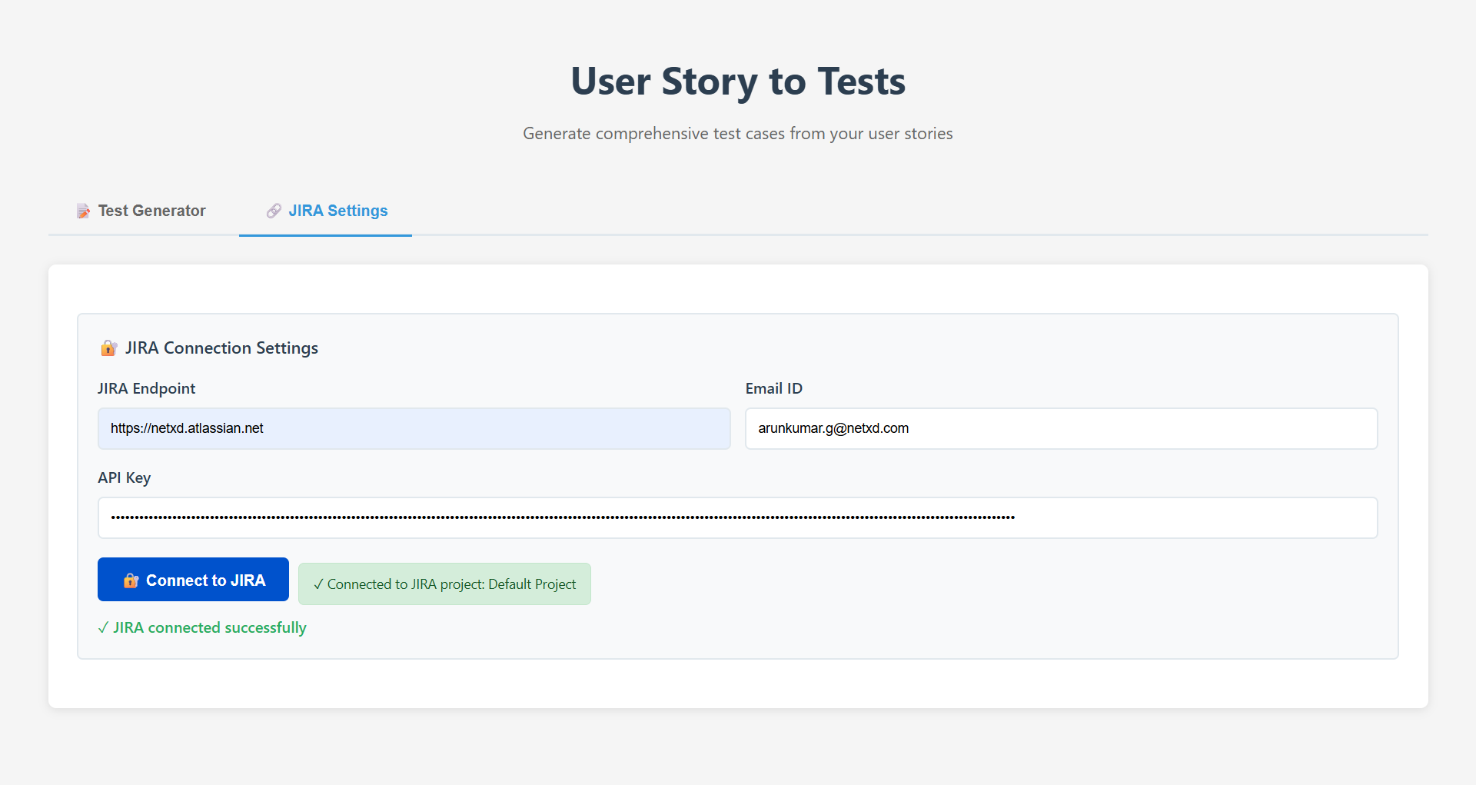
- Implemented search to fetch the details from JIRA by Key ID
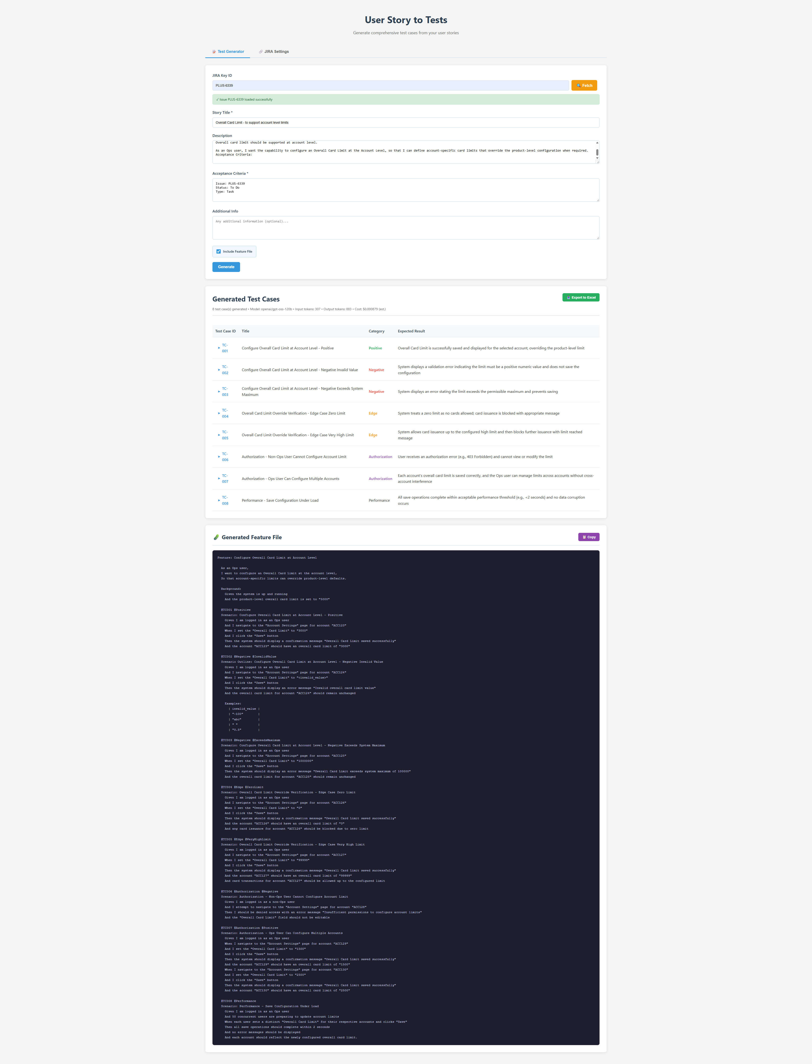
- Added Export generated test cases to excel
